
Detailed Project Report

BUDGET SALES
ANALYSIS

Written By | Adil Anwar
Version | 1.1
Last Date of Revision | 25-10-2022

Document Change Control Record
Version | Date | Author | Comments
1.0 | 18-10-2022 | Adil Anwar | Abstract  Introduction  Architecture
1.1 | 25-10-2022 | Adil Anwar | Architecture Design

OBJECTIVE

- Extract various information such as Sales, budget, variance.

- comparing sales, profit, income and budget with various attributes.

- Extract necessary information about Products and Customers.

- Do ETL : Extract, transform and Load the data

- Use various visualization and features and make the best dashboard.

- Find key metrics and factors and show the meaningful relationships between attributes.
Benefits

- Analyzing the Revenue and Sales of various items.

- Determining the budget in the year of 2016

- Extracting the flows and achievements

- Detecting the trends of Profit in each Fiscal years

Data Sharing Agreement :

- Sample file name

- Length of date stamp(8 digits)

- Length of time stamp(6 digits)

- Number of Columns

- Column names

- Column data type
Architecture

Start

Import data
(Excel, .CSV,
Data Base and
many)

Extract
Data(Power
Query)

Exploratory Data | Data
Analysis | Visualization
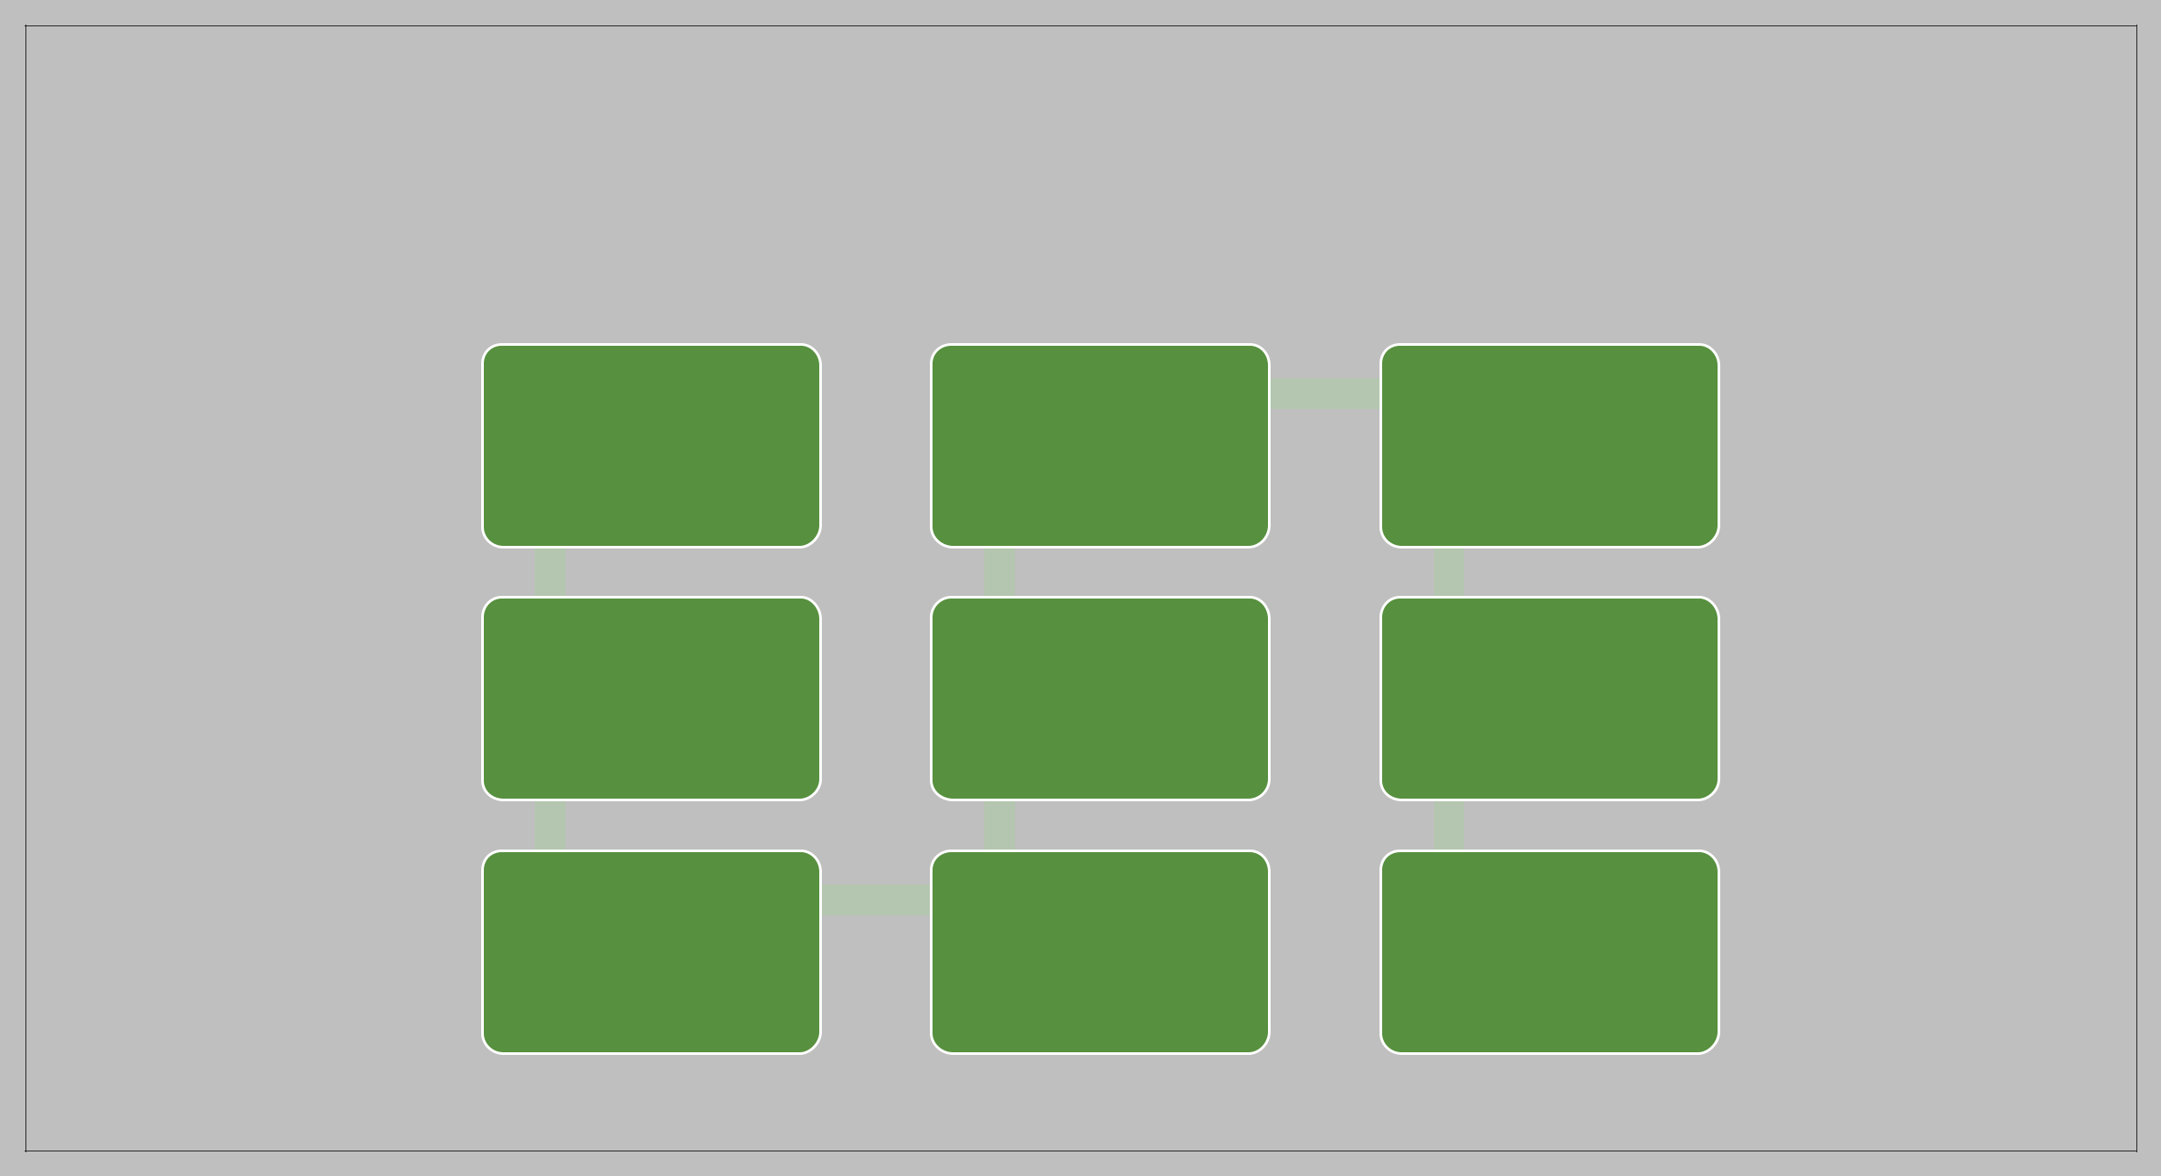

Load
Data(Power Deployment
Query)

Transform
Data(Power END
Query)
Data Validation and Data Transformation :

- Name Validation - Validation of files name as per the DSA. We have created a

- regex pattern for validation. After it checks for date format and time format if

- these requirements are satisfied, we move such files to "Good_Data_Folder" else

- "Bad_Data_Folder.“

- Number of Columns – Validation of number of columns present in the files, and if

- it doesn't match then the file is moved to "Bad_Data_Folder.“

- Name of Columns - The name of the columns is validated and should be the same

- as given in the schema file. If not, then the file is moved to "Bad_Data_Folder".

- Data type of columns - The data type of columns is given in the schema file. It is

- validated when we insert the files into Database. If the datatype is wrong, then the

- file is moved to "Bad_Data_Folder".

- Null values in columns - If any of the columns in a file have all the values as

- NULL or missing, we discard such a file and move it to "Bad_Data_Folder".
Data Insertion in Database:

- Table creation :- Table name “t_motorpv_fraud" is created in the database for

- inserting the files. If the table is already present then new files are inserted in the

- same table.

- Insertion of files in the table - All the files in the "Good_Data_Folder" are inserted

- in the above-created table. If any file has invalid data type in any of the columns,

- the file is not loaded in the table
Q&A:

- Q1) What’s the source of data?

- The data for training is provided by the client in multiple batches and each batch contain multiple files

- Q 2) What was the type of data?

- The data was the combination of numerical and Categorical values.

- Q 3) After the File validation what you do with incompatible file or files which didn’t pass the validation?

- Files like these are moved to the Achieve Folder and a list of these files has been shared with the client and we removed the bad data folder.

- Q 4) How logs are managed?

- We are using different logs as per the steps that we follow in validation and modeling like File validation log , Data Insertion , Data Visualization etc.
- Q 6) What techniques were you using for data pre-processing?

- Removing unwanted attributes

- Visualizing relation of independent variables with each other and output variables

- Checking and changing Distribution of continuous values

- Removing outliers

- cleaning data and imputing if null values are present.

- Converting categorical data into numeric values.

- Scaling the data

- Q 9) What are the different stages of deployment?

- When the model is ready we deploy it in Fire environment .Where SIT and UAT is performed over it . Once We get Sign off from Fire we deploy in Earth and UAT is performed over it. After getting the sign off from Earth we deploy in production

